Урок 25 сентября

Appearance

1. **Revision**

Watch a video:

* <https://www.youtube.com/watch?v=Wf5GaEQ3rCI>
* <https://yandex.ru/video/preview/?filmId=13142449019085605812&text=описание+внешности+по+англ+д7+класс+видео&path=wizard&parent-reqid=1588101015185994-1149998966642844607400287-production-app-host-vla-web-yp-81&redircnt=1588101055.1>(4 мин)

1. **Practice**

**Ex. 1**

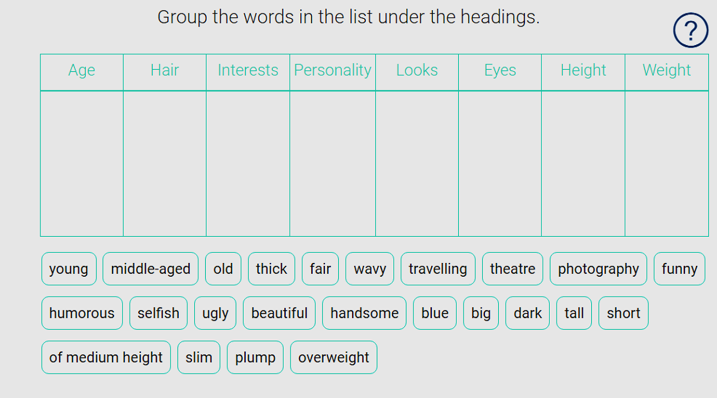

**Ex.2**

**Complete the text with the words:**

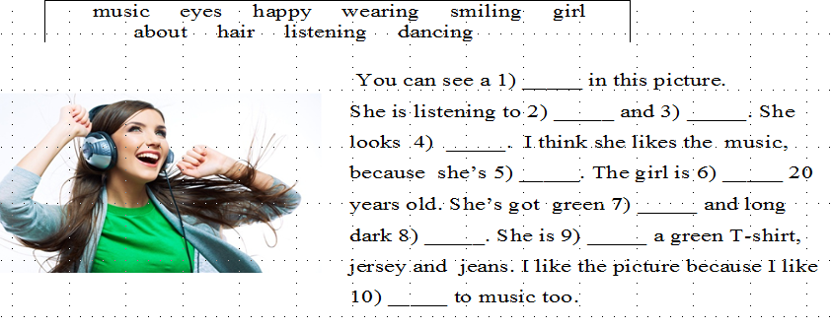

1. **Speaking. Choose 1 photo. Describe the photo.** Speak for not more than 2 minutes (10-15 sentences). ***Start with (начни так): I’ve chosen the photo number 1\2\3\4\5*** Speak about:

* **the place**
* **the appearance of the person**
* **the action**
* **whether you like the picture or not**
* **explain why**

**1**

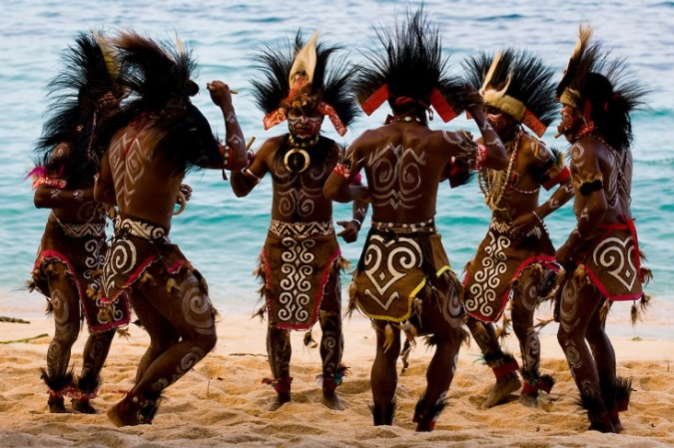

**2**



**3**

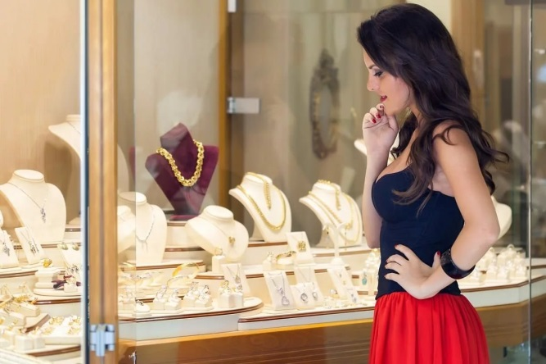

**4**



**5**



**Используй следующие фразы:**

1. **Вступление**

So, I would like to start with a general description.

The photo\picture shows……

On this photo\ picture I can see …….

It’s a black and white \ coloured photo\picture.

1. **The place (where?)**

_____ **is\ are in\at\on\.............**

In the foreground I can see ……..

In the background there is\are…….

In the centre there is\are……

**3.Describing people\ things \weather. Описание людей\ предметов\погоды**

**(Appearance – внешность) What does he\she\it look like? What is he\she\it like?**

* He\she\it is + прилагательное
* He\she\it has got ………… hair.
* He\she\it has got ………. eyes.
* He\she is wearing……….

weather

It is spring\ summer\autumn\winter.

It is sunny\ cloudy\ rainy\ warm\hot\ cold**.**

**4.The action – действие What is he\she\it doing? What are they doing?**

Расскажите чем занимаются действующие лица? Для описания действий используйте Present Continuous. He\she\it **is + Ving**

They **are + Ving**

**5.Your opinion- твоё мнение  
Do you like this photo\picture or not? Why do you like\ don/t like this photo\ picture**

I like this photo\picture because …….

I don’t like this photo\ picture because…..

**Выполни интерактивные задания** [**https://edu.skysmart.ru/student/vehetanatu**](https://edu.skysmart.ru/student/vehetanatu)