**The 18th of October.**

**Classwork**

**My day.**

1. **Warm up. Remember the reading rules. Read. Вспомни правила чтения. Прочитай.**

a [ei] cake, take, wake, make

[ǽ] bag, cat, snack,

ar [a:] park, car, carpet,

o [ɒ] stop, from, dog, got

[eʊ] go, home, rose

or [ᴐ:] morning, horse,

oo [ʊ:] book, look, noon

ea [i:] eat, meal, leave

1. **Match the words to make phrases. Соотнеси слова, составь фразы. Устно**

|  |  |
| --- | --- |
|  |  |
| **go**  **do**  **have**  **clean**  **get** | **a bath** |
| **to school** |
| **breakfast** |
| **lunch** |
| **teeth** |
| **up** |
| **homework** |
| **to bed** |
| **home** |

1. **Посмотри видео по теме** <https://www.youtube.com/watch?v=qD1pnquN_DM>
2. **Повтори правило**

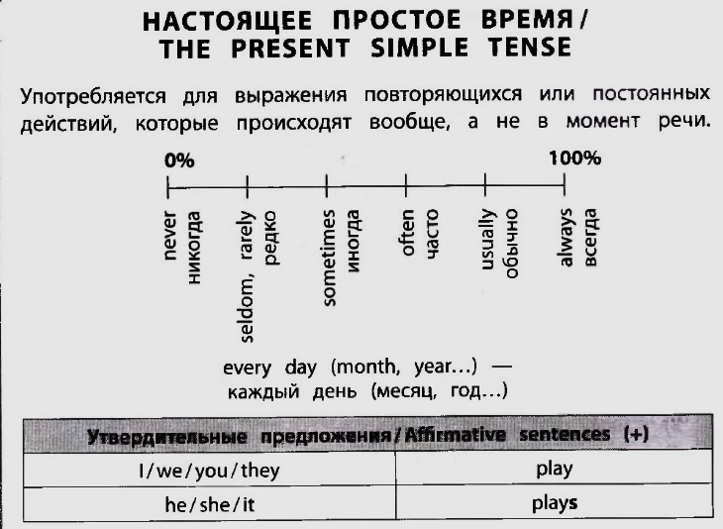

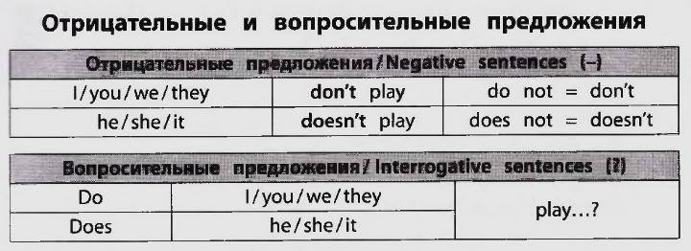

1. **Посмотри видео** [**https://dzen.ru/video/watch/63486dd995278208867607ec?f=d2d**](https://dzen.ru/video/watch/63486dd995278208867607ec?f=d2d)
2. **Выполни упражнения в тетради**

**Ex 1**



**Ex 2**



**Ex 3**

