***Конспект урока английского языка для 8 класса на 18.10.24***

Good morning, children!

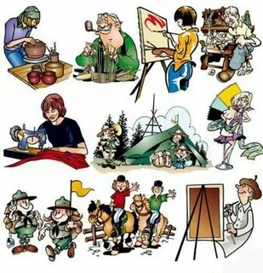

What do the pictures show?

What will we have a talk about today?

So. What is the theme of our lesson?

Today we are going to talk about different types of free time activities and know some ways how to spend free time with pleasure.

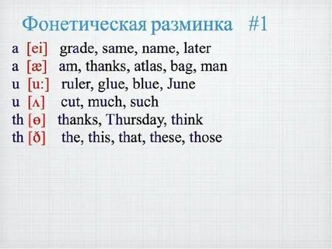

***Откройте словари, запишите новые слова:***

square-eyed generation – поколение с квадратными глазами

couch potatoe – лежебока

teenager - подросток

(The phrase “ **square** –**eyed** **generation**” describes teens who do nothing else but watch TV. Also they spend a lot of time using computers).

be keen on — сильно увлекаться

be crazy about — обожать

knitting – вязание

sewing – шитье

travelling – путешествия

diving – дайвинг

blogging – ведение блогов

doing arts and crafts – мастерить поделки

pottery – гончарное дело

doing crosswords – разгадывание кроссвордов

doing puzzles – собирать пазлы

learning foreign languages – изучение иностранных языков

hunting – охота

**Read short texts and guess what hobby it is.** (Запишите свои ответы в тетради)

1) Such people like to visit different cities, towns and historical places. Some

people even visit other countries. They can travel by car, by plane, by train, by bus or on

foot. This hobby helps them to learn history, geography and traditions of different people

and countries.

2) People like to spend their free time near the rivers or lakes. They often go there

with their friends or relatives. They can have a picnic there. They go usually there in

summer but some people like to go there in winter too. Also they can boil fish broth

(soup) after going there.

3) This hobby is interesting and useful. People try to find or buy different things

such as stamps, badges, coins, pictures and dolls. Their collection can be thematic. This

hobby helps people to make new friends and to learn some new things about countries

and lands, animals and birds, famous people and historical events.

4) This hobby is popular with the people of all ages. People like to go to the

stadium or to the sports ground. They are strong and healthy. Their hobby helps to

develop their mind and body and teaches them to plan their time.

5) People like to go to the library. Some of them have a good collection of books at

home. And they are really proud of it. They can have different books: fiction, historical

novels, books about animals and birds, books about different countries. Their hobby

helps them to relax, to learn the world and understand people better.

(Запишите свои ответы в тетради)

Желаю удачи!