**Урок 14.02**

**Animals. Revision.**

1. **Revision. Name the animals’ body parts.** Вспомни части тела животных.

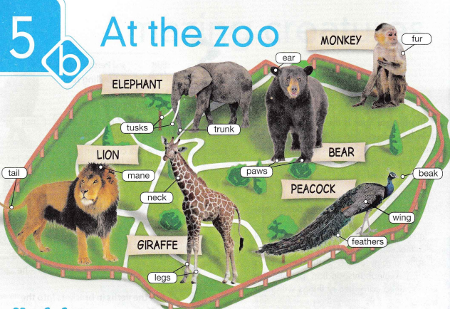

1. **Watch a video.** Посмотри видео <https://www.youtube.com/watch?v=M1IDQSeJ1cs>
2. **Read and guess. Прочитай и отгадай. (устно)**

**Panda, elephant, monkey, giraffe, ostrich, lion**

1. It loves to climb trees. It has a long tail.
2. It has a long neck and long legs. It can't fly but can run fast.
3. It has a long tail. It eats other animals.
4. It's black and white. It eats bamboo.
5. It has long neck. It eats leaves from tall trees.
6. It has two big ears and eats leaves.
7. **Practice**. Выполни интерактивные задания <https://edu.skysmart.ru/student/fihikazunu>