**Конспект урока английского языка для 8 класса на 13.02.25**

**«Природа. Флора и фауна»**

Здравствуйте дорогие ребята!

Выполните фонетическую зарядку:

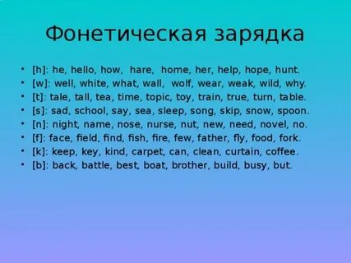

Посмотрите видеоурок на платформе РЭШ по нашей теме, выпишите незнакомые слова: <https://resh.edu.ru/subject/lesson/2848/main/?ysclid=lsll0xos4b372527735>

Выполните упражнения в тетради:

Match the words with their meanings.

|  |  |
| --- | --- |
| insects  species  fauna  wildlife  flora | all the animals that live in a particular area  a plant or animal group whose members all have similar general features  small animals that have six legs and often have wings  all the plants that grow in a particular area  animals, birds, and plants that live in natural conditions |

Match the pictures and the words.

|  |  |
| --- | --- |
|  | Hedgehog  robin redbreast  seals  starling  otter |

Guess the animals and birds.

A  is a wild animal similar to a large dog that lives in groups.

A  forms a shape like a ball when it is threatened.

A  is the national bird of Britain.

A  is a small animal with long ears and soft fur that some people keep as a pet.

A  is a small brown bird that is common in the UK and northern Europe.

**Wolf hedgehog robin redbreast rabbit sparrow**

Complete the text with the corresponding words.

There are many interesting native__1__ in Britain, some very rare indeed. Different kinds of birds, fish, and ___2__that can be found here. There are many foxes, hares, rabbits, and __3__. Various species of__4__ , whale and dolphin are found on or around British shores and coastlines. Well-known__5__  species of Great Britain include the golden eagle, pigeon, and sparrow.

***Species mammals deer seal bird***

Желаю удачи!