**Урок 14.02**

**Animals in danger.**

**1.Warm up**.

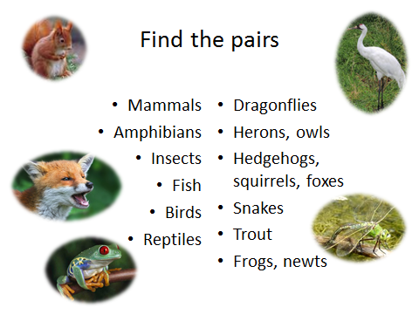

**2. Watch a video lesson** [**https://resh.edu.ru/subject/lesson/3031/main/**](https://resh.edu.ru/subject/lesson/3031/main/)

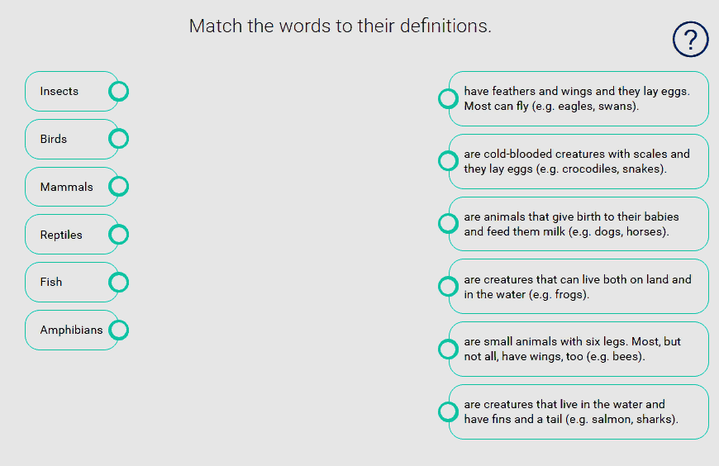

3. **Practice.** **Read the text and complete the table.**

**Panda**

* Panda lives in bamboo forests of central China.
* Panda has a black and white coat, she large black patches around its eyes.
* Panda is an endangered species. There are about 2000 pandas living in the wild.
* Adult panda can weigh up to 150 kg.
* Giant panda lives about 20 years in the wild.
* Giant panda eats as much as 10 kg of bamboo a day.
* Giant panda is a good climber.
* The panda’s food is bamboo. Bamboo also serves as their shelter in the wild, as panda lives in the cold bamboo rain forests in China. People cut down bamboo trees because of farms, roads and industrial area. People must take special care of them, they must save pandas.

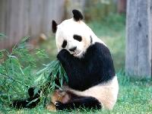

1) Name _________________________________________  
2) Size __________________________________________

3) Area of living ___________________________________

4)Food ___________________________________________

5) Number _________________________________________

**White Bears**

Many animals and birds are disappearing nowadays. Many of them are in danger. White bears are among them.

White bears are very strong animals. They are one of the biggest wild animals in the world. They live in the North of our country on the banks of the Arctic Ocean. White bears eat fish and sea animals. They weigh 500 kilograms. Sometimes they catch and eat birds. There are about 23000 white bears left .

For many years people have hunted and killed many white bears. The result is very sad. There are few white bears in our country. “People must take special care of them, they must save white wears.

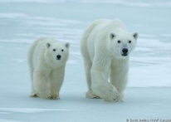

1) Name _________________________________________  
2) Size __________________________________________

3) Area of living ___________________________________

4)Food ___________________________________________

5) Number _________________________________________

1. **Выполните интерактивные задания** <https://edu.skysmart.ru/student/suxubusotu>