**Урок 14.02**

**Environmental problems.**

1. **Write the words and translate them.**

to pollute

pollution

to protect

waste

to waste

cause

to cause

dangerous diseases

to release

to destroy

to damage

2. **Read, translate.**

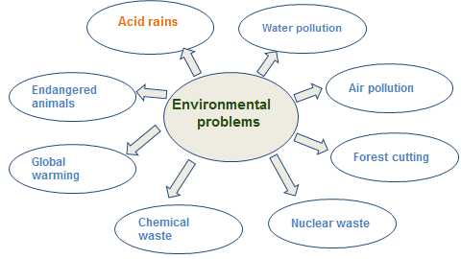

**3 Watch a video lesson <https://resh.edu.ru/subject/lesson/3498/main/136027/>**

4. **Match the texts with the problems:**

**Air pollution, global warming, acid rains, water pollution, chemical waste.**

1. One of the most dangerous problems for our planet .Most climates all over the world are changing and getting warmer. It happens because we burn too much petrol resources, such as oil and coal, and the Earth heats up. This process can cause melting of the polar ice and the sea level rising in the future. If the climate changes there will be floods, heavy storms or severe droughts in different areas of the world.
2. People face to air pollution for a long time. Factories and plants release lots of gases and smoke. It causes air pollution and destroys environment. People, animals and plants suffer from it.
3. People like to spend their free time on the banks of rivers. They have picnics and make fires . Unfortunately, people often forget about nature. They leave cigarette butts, trash, plastic bottles and glass on the riverbank. Fish, animals, and people can get hurt.
4. Polluting the air with industrial emissions and car smoke leads to the formation of acid rains. Acid rain destroys nature, damages buildings, and causes dangerous diseases.
5. Modern enterprises are developing rapidly. But at the same time, a huge amount of waste needs to be recycled. People throw chemical waste into the ocean and pollute the water. Animals,plants and people suffer from it.

**4. Выполните интерактивные задания** [**https://edu.skysmart.ru/student/rudutozaxa**](https://edu.skysmart.ru/student/rudutozaxa)