**Конспект урока английского языка для 2 класса на 06.05.25**

Здравствуйте, ребята! Устно прочитайте слова по картинке:

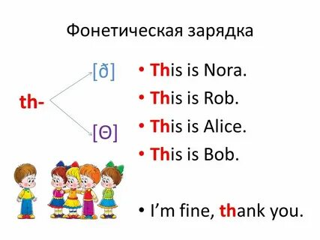

Запиши в тетради число по образцу:

The 6 th of May.

Homework

**Прочитайте рассказ. Выпишите имена существительные во множественном числе.**

I am a little bunny. My name is Tim. I live in a wood. My house is in the hollow tree.

In spring, I like to pick roses. These flowers are very nice, sweet and tasty. In summer I listen to the birds and insects. In autumn I watch bright leaves on the trees. In winter I dream about spring.

**Раскройте скобки, запиши имена существительные во множественном числе.**

I have two little (a sister). They are (a twin). They have a lot of (a pencil) and (an album). They like to draw (a house, a tree, a puppy, a kitten, a duck, a chicken and a doll).

Желаю удачи!