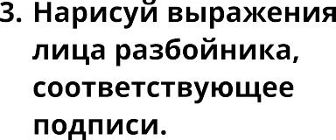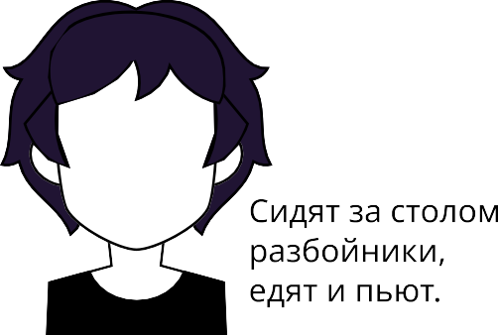Тема урока : **Работа со сказкой братьев Гримм «Бременские музыканты»: составление плана произведения.**







