

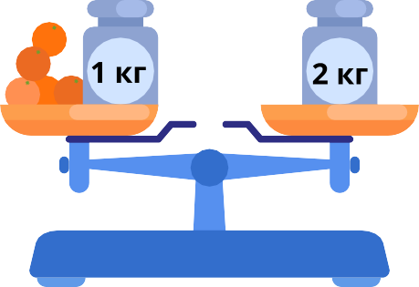

Тема урока ; **Работа с величинами: сравнение по массе (единица массы — килограмм)**





                                      
                                      
                                      
                                      
                                      
                                      
                                      
                                      
                                      

