**Конспект урока английского языка по теме**

**«Обобщение по теме "Родная страна и страна (страны) изучаемого языка. Их географическое положение» для 7 класса на 6.05.25**

Здравствуйте, дорогие ребята!

*Перед тем как читать текст про Великобританию, найдите на карте географические названия ниже, запишите их в словарик:*

1. the British Isles [‘brɪtɪʃ  aɪlz]- Британские острова ( Great Britain & Ireland)
2. the Irish Sea — Ирландское море
3. the English Channel — пролив Ла-Манш (другие названия пролив Па-де-Кале)
4. the Strait of Dover — Дуврский пролив
5. the North Sea – Северное море
6. the Atlantic Ocean – Атлантический океан
7. England — Англия
8. Scotland — Шотландия
9. Wales – Уэльс
10. the UK – Соединенное королевство
11. Northern Ireland – Северная Ирландия
12. Dover – город Дувр

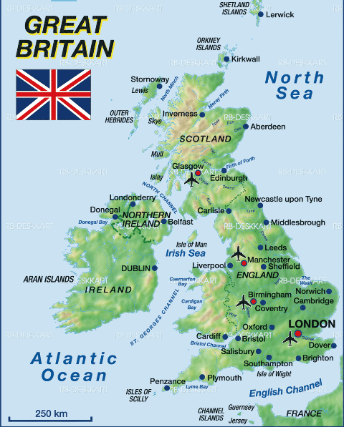

**Great Britain**

**The United Kingdom of Great Britain and Northern Ireland (the UK)** is the official name of the state, which is situated on the British Isles. This state is also called Great Britain after the main island with the same name. The UK consists of four countries, which are England, Scotland, Wales and Northern Ireland. Their capitals are London, Edinburgh, Cardiff and Belfast.

**Geographical position of the UK. Географическое положение Соединенного королевства**

The UK is an **island state.** The two main islands are Great Britain (where England, Scotland and Wales are situated) and Ireland (where Northern Ireland and the independent Irish Republic are situated). The two islands are separated by **the Irish Sea. The UK** is washed by **the Atlantic Ocean** in the north and **the North Sea** in the east.

The UK is separated from the continent by **the English Channel** and **the Strait of Dover.** The Strait of Dover is the narrowest part of English Channel. The nearest point to Europe is **Dover**which is only thirty-two miles from France. Dover is one of the most ancient ports. If you cross the English Channel by ferry you can see **the white chalk cliffs of Dover** and **Dover Castle.**

**Nationalities. Национальности**

Everyone who was born in Britain is British. People from England are English. People from Scotland, Wales and Northern Ireland are not English. They are Scottish or the Scotts, Welsh and Irish.

**Languages. Языки**

Everyone in Britain speaks English. But in some parts of Scotland and Wales people speak different languages as well. The Welsh are especially proud of their language. They like to speak Welsh, to sing songs in Welsh and when you travel you can see road signs in Welsh all over Wales. Everyone in the UK speaks English but they all speak it differently. A Scottish person has to listen carefully if he wants to understand a Londoner or a Welsh person.

Письменно выполните упражнения в тетради:

**Упражнения к тексту «Great Britain»**

**Упражнение 1.***Read the text and complete the following sentences:*

1. … is the official name of the state which is situated on the British Isles.
2. The capital of Great Britain is …
3. The capital of Scotland is …
4. The capital of Northern Ireland is …
5. The capital of Wales is …
6. Ireland and Great Britain are separated by …
7. The UK is separated from the continent by …
8. The UK is washed by… in the west.
9. The UK is washed by … in the east.

**Упражнение 2.***Complete the following sentences making the right choice.*

1. The Union Jack is …
   1. the flag of the UK
   2. the flag of the USA
2. English is spoken …
   1. all over Britain
   2. only in England
3. The UK is the official name of the country situated …
   1. on the island which is called Great Britain
   2. on the British Isles
4. Edinburgh is the capital of …
   1. Wales
   2. Scotland
5. The independent Irish Republic is situated …
   1. in Northern Ireland
   2. on the smaller of the two biggest islands of the British Isles
6. Great Britain and Ireland are separated by …
   1. the North Sea
   2. the Irish Sea
7. The nearest point to Europe is …
   1. the Strait of Dover
   2. Dover
8. The UK is washed by the Atlantic Ocean in …
   1. the north
   2. the west

Желаю удачи!